**DSP Experiment 4**

**Problem Statement:**

Write a sample user interactive script to study the effects of following windows for Linear Phase FIR digital low pass filter. The script must take cutoff frequency and length of the filter as an input. Plot the frequency response of the same. 1) Rectangular 2) Triangular   
3) Hanning 4) Hamming 5) Kaisers

**Code:**

clc;

clear;

close all;

% t = linspace(-50,5);

wc=input("Enter Cutoff frequency: ");

t=0:0.1:2*pi/wc;

y = wc*sinc(wc*(t));

plot(t,y)

M=input('Enter the length of filter:(100, 200, 500):');

w1=boxcar(M); % Rectangular

w2=triang(M);

w3=hanning(M);

w4=hamming(M);

w5=blackman(M);

w6=kaiser(M);

% plot(t,w);

s1=conv(w1,y);

s2=conv(w2,y);

s3=conv(w3,y);

s4=conv(w4,y);

s5=conv(w5,y);

s6=conv(w6,y);

figure()

subplot(231)

plot(s1);

title('Response with rectangular window');

subplot(232)

plot(s2);

title('Response with triangular window');

subplot(233)

plot(s3);

title('Response with Hanning window');

subplot(234)

plot(s4);

title('Response with Hamming window');

subplot(235)

plot(s5);

title('Response with Blackman window');

subplot(236)

plot(s6);  
title('Response with Kaiser window'); **Output:**

For Cutoff Frequency=0.5, Length of Filter=100  
  
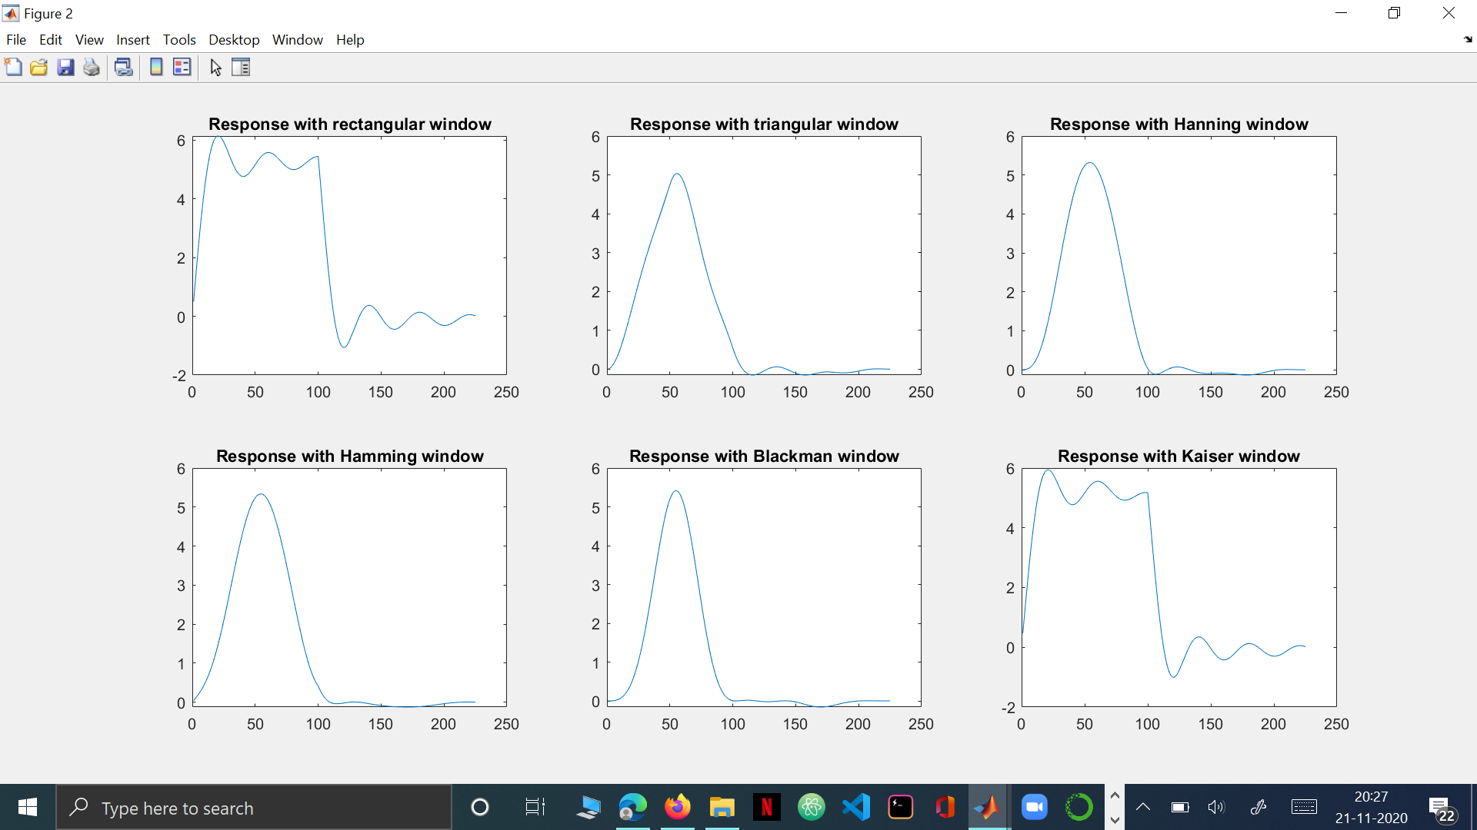  
  
For Cutoff Frequency=0.5, Length of Filter=200  
  
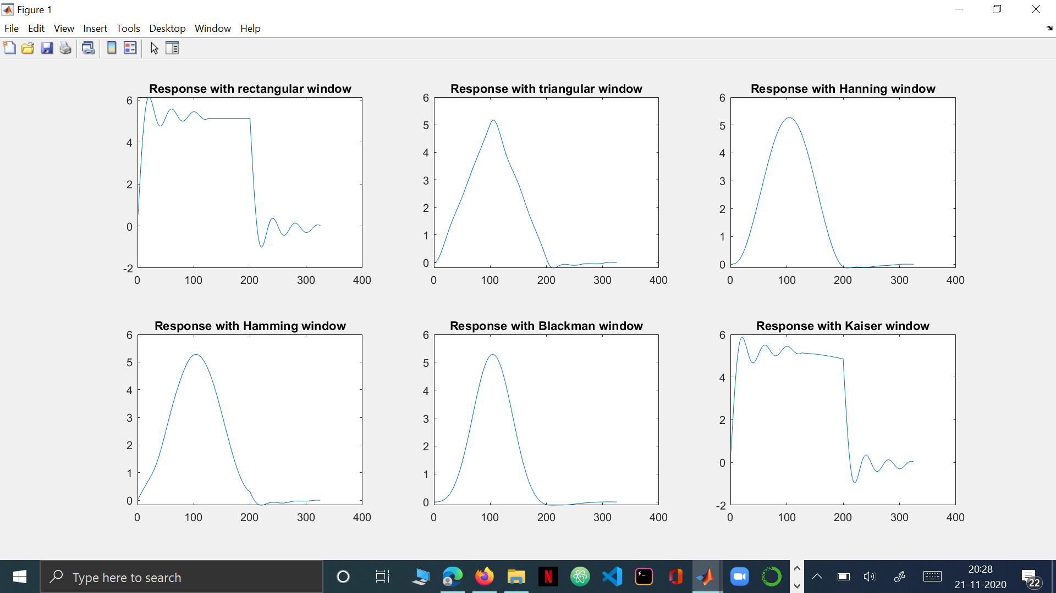  
  
  
For Cutoff Frequency=0.8, Length of Filter =100  
  
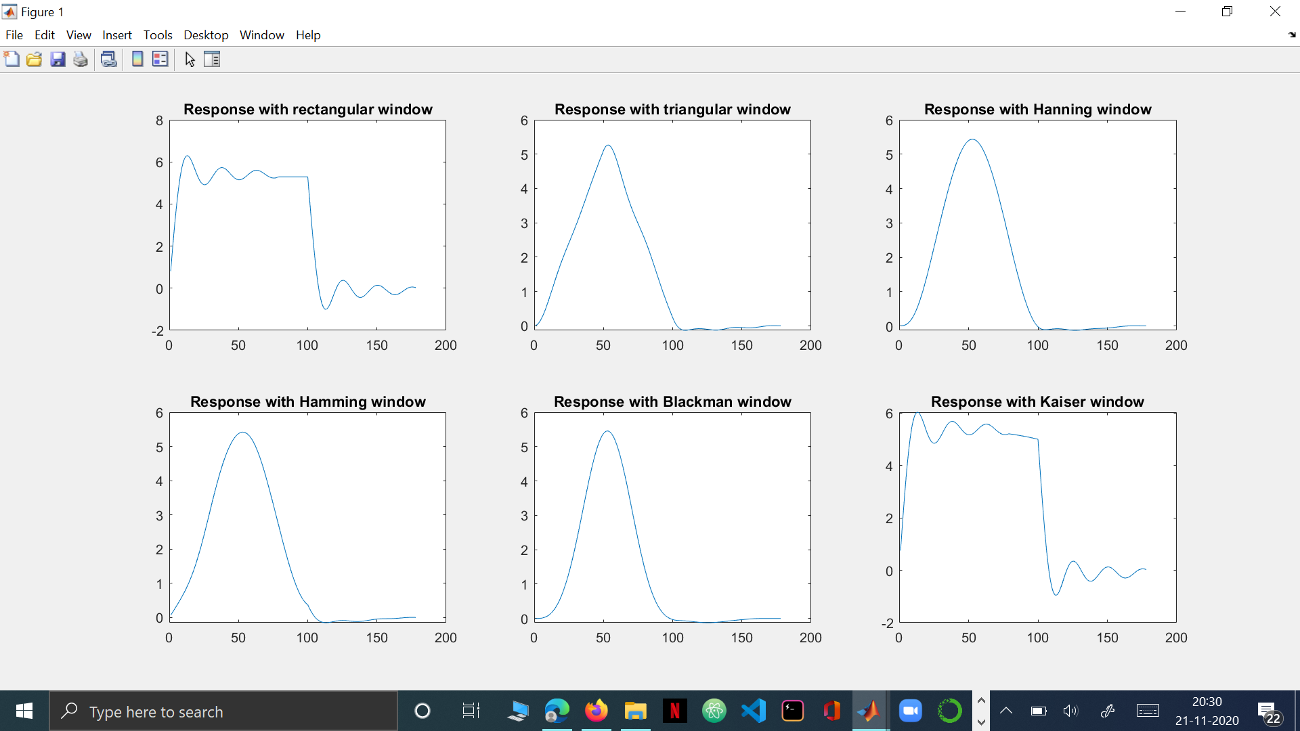  
  
For Cutoff Frequency=0.8, Length of Filter =200  
  
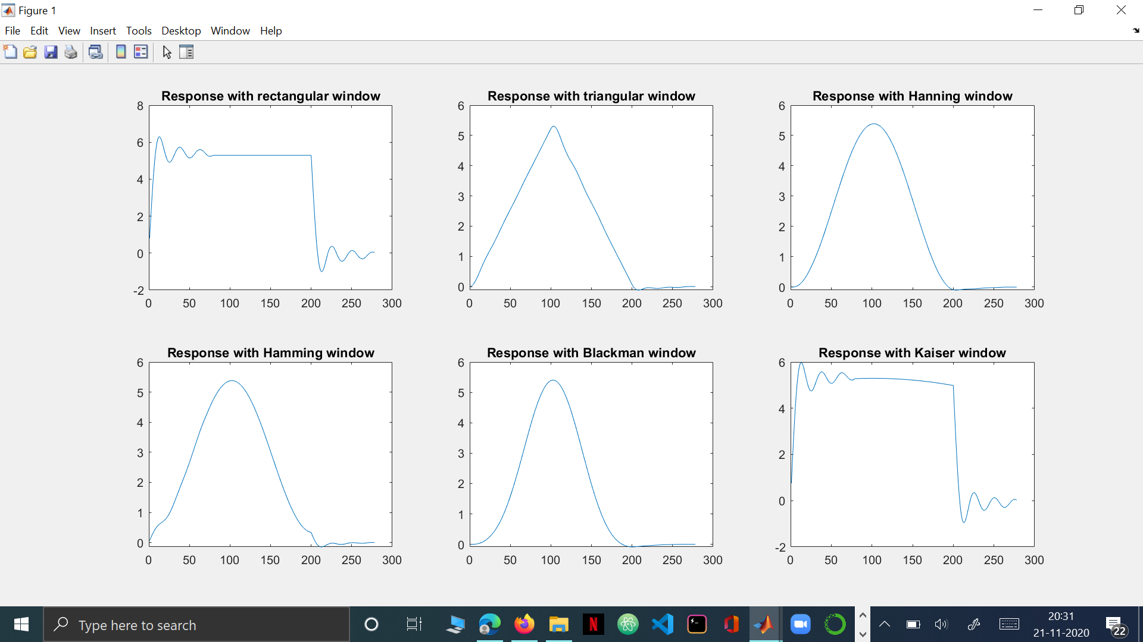

**Conclusion:**All the outputs which were obtained from the above code had a constant input signal. Further, I took two different inputs for cutoff frequency and for the same cutoff frequency, two different filter lengths were taken. But it was observed that changing the cutoff frequency from 0.5 to 0.8 for a same filter length, doesn’t show bigger change in the final plot. This means that the filter length is the deciding factor for the presence of oscillations in the frequency response curve. Since Kaiser and Rectangular windows have the maximum number of oscillations in the final plot, we can then conclude that they are not ideal for our purpose of filter designing.